HGTW Conference Newsletter April 2023
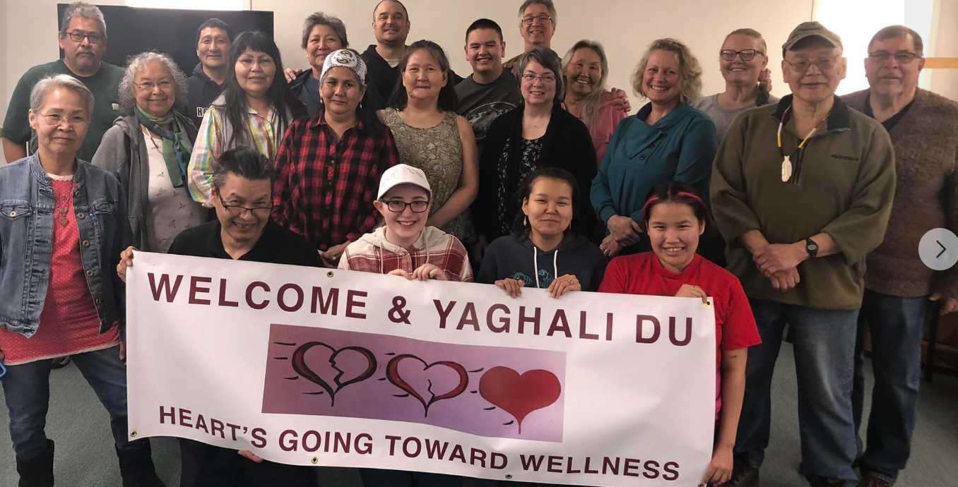

Our April 2023 HGTW Conference was amazing. Many blessings, breakthroughs and burdens were shared. Here is what some of the leaders and participants are saying:
“This is a valuable ministry and I would like to see it expand and go to villages as well.”
“I am truly honored to be a leader amongst everyone. I feel very blessed and strengthened.”
“I think by far the conference in every aspect went well. Jesus won! And He will again. I personally got blessed and strengthened. I would say keep this ministry going, at any cost.”
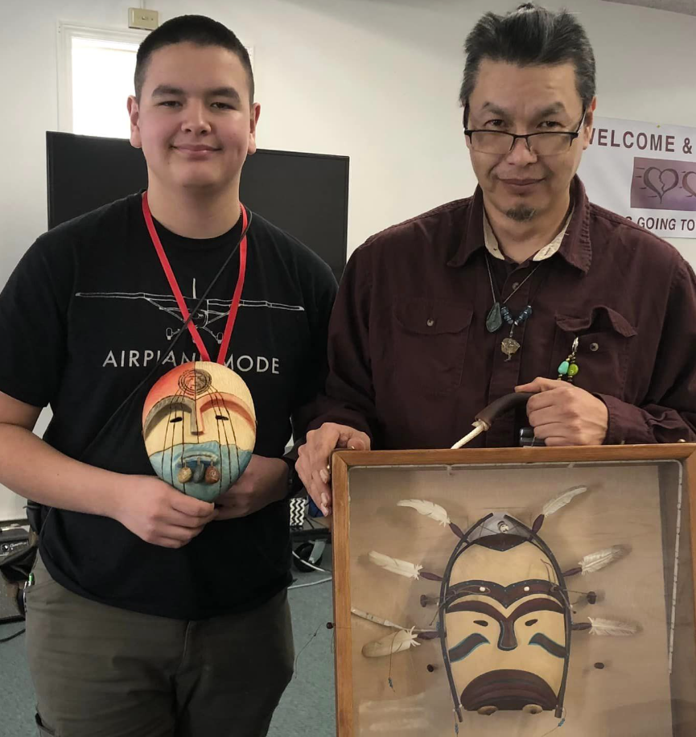
“I felt like I did a lot more work this time around than the previous two sessions I’ve done.”
“If I needed a question answered, someone would explain.”
Up-coming Events
October 2023 Conference
April 2024 Conference
See heartsgtwellness.org for
Exact dates and applications
Contact Information:
Linda and Alan Ross 907-952-2847
aross@gci.net
Lydia Wood 907-982-7695
Wood.lydia.g@gmail.com
See more on FaceBook Hearts Going Toward Wellness
Website heartsgtwellness.org
Invitation: Please plan to come to one of our conferences on beautiful Lazy Mountain just outside of Palmer, Alaska. We have the best cook in Alaska on our staff. The conferences are held in both April and October each year. The five-day conference is designed to help adult survivors of trauma and abuse find hope, healing and freedom with the Lord Jesus Christ, our Wounded Healer. If you think this conference is right for you or someone you know, please attend, or sponsor a participant. Learn how you can grow in Jesus and share Him with others at Hearts Going Toward Wellness. See heartsgtwellness.org for exact dates and applications.

Exact dates and applications

